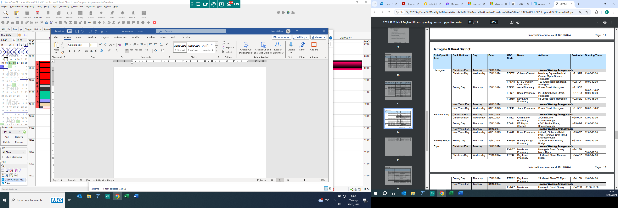

|  |  |  |  |  |  |  |  |  |
| --- | --- | --- | --- | --- | --- | --- | --- | --- |
| Boroughbridge | Christmas Eve | Tuesday | 24/12/2024 |  | The Pharmacy | 26 High Street, Boroughbridge | YO51 9AW | 09.00-18.00 |
| Christmas Day | Wednesday | 25/12/2024 |  | Closed |
| Boxing Day | Thursday | 26/12/2024 |  | Closed |
|  | Friday | 27/12/2024 |  | 09.00-18.00 |
|  | Saturday | 28/12/2024 |  | 09.00-17.00 |
| New Years Eve | Tuesday | 31/12/2024 |  | 09.00-18.00 |
| New Years Day | Wednesday | 01/01/2025 |  | Closed |

Information correct as at 17/12/2024